Microbiology Practical Lab Report
Student’s Name
Institution Affiliation
Professor’s Name
Course
Date

Introduction
Bacterial identification procedures are so necessary that they help establish the taxonomic classification of a certain bacteria extracted from a patient, identifying a microbial impurity that may make food become bad, establishing a new identity of a certain isolate performs a crucial task. The Gram stain and metabolic tests are used to identify bacteria. The Gram stain is used to show how different gram-positive organisms are from gram harmful organisms. The two organisms are different in their cell walls, and they affect several cell aspects. Gram-positive cells assume the crystal violet that is attached to the cell with the iodine mordant leading to a crystal-violet iodine complex inherent in the cell. As the Gram-positive cells, the Gram-negative cells, in the same way, assume crystal violet, the iodine forming a crystal violet-iodine complex in the cells, which is not inherent.
Metabolic tests involve biochemical reactions that clearly bring out the critical information needed for accurate and precise establishment of the nature of a variety of bacteria in a sample. Basically, bacteria release several enzymes, which make it possible for their identification through biochemical methods. Different bacteria have different enzymatic properties. Each bacterial species has unique metabolic requirements and depends upon different enzymes to satisfy the unique requirements. Enzymes whose presence can be used to tell the bacteria species include catalase, gelatinase, oxidase, urease. Staining procedures alone are not sufficient for bacterial identification because they do not provide enough information about the bacterial organism to make a detailed identification. It only gives some essential clues.

Methods
Gram stain
The unknown specimen was smeared and the smear saturated with crystal violet for 1 minute. Water was passed through the slide that held the specimen. Iodine was used to saturate the smear for a minute. Water was passed through the slide containing the specimen, and decolorization done with Gram decolorizer for 4 seconds. Water was passed through the slide that held the specimen. Counterstaining using safranin was done for a minute. Water was passed through the slide that had the specimen. Blotting the slide was done using bibulous paper and the slide viewed using proper microscope technique.

Metabolic tests
Catalase
A microscope slide was placed inside a petri dish. The petri dish cover was kept available. A sizeable quantity of organisms was collected from an isolated 22-hour cluster of bacteria and positioned on the slide using a sterilized protecting loop. By the use of a dropper, one drop of 2% H₂O₂ was added to the organism on the slide. The petri dish was secured using a lid to restrict vaporizers and checked for immediate effervescing against the dark background.
We expect to bubbles to be produce as a proof of catalyse enzyme. Bacteria sample has the ability to synthesize catalyse enzyme which in turn hydrolyzes H₂O₂ into H₂O and O₂.
Enzymatic equation
H₂O₂ H₂O+ O₂
Indole test
Tryptone broth was disinfected with pure culture. Incubation was done at 37ºC for 36 hours. To determine whether indole was being produced, 6 drops of Kovac’s reagent were added to the tube (Das et al., 2019). A positive result is shown by red colour in the surface layer of the broth while a negative result would appear yellow. The red color of a positive result is due to a chain of reactions. Para-Dimethylaminobenzaldehyde has a reaction with indole in the medium to form red rosindole dye (Das et al., 2019).

Gelatinase test
The gelatin was inoculated with 4 to 5 drops of 4-hour broth culture. Incubation was done at 35- deep 37ºC in ambient air for up to two weeks. The gelatin duct was taken out on a daily basis from the incubator and kept at 4ºC to check for liquefaction. A non-disinfected control was refrigerated alongside the inoculated tube as Liao et al (2019) recommends.
Gelatinase is a protease produced by a bacteria which breaks down gelatin. The secretion of gelatinase is used to determine the presence of organisms like Staphylococcus sp., Enterobacteriaceae. The test determines whether an organism can secrete gelatinase enzyme that liquefy gelatin. The reaction happens in two phases: in the first phase gelatinase enzyme breaks down gelatin into polypeptides which are then transformed into amino acids. The existence of gelatinase is perceived by the aid of nutrient gelatin agent. When an organism secretes gelatinase enzyme, the produced enzyme causes the growth agent to liquefy by breaking down the gelatin in the agent.
Lactose fermentation test
The medium was allowed to attain room temperature before disinfection. The broth was inoculated with a secluded cluster of bacteria from a 22-hour bacterial culture. As Gajdács et al (2020) urges, purple tube of potage base was inoculated alongside the medium consisting of carbohydrates. The disinfected media was inoculated at 36ºC for four days. Observation for the development of yellow color was done daily.
Microorganisms secrete energy by utilizing the process of fermentation of carbohydrate. A fermentation agent is made of a basal agent with one carbohydrate e.g. sucrose. The agent also has pH indicators. Diverse organisms exhibit dissimilar fermentation forms and thus bacterial species can be easily distinguished from others. The purple tube has peptone which in turn has pH indictor called bromcresol purple. A suitable concentration of carbohydrates, like 0.9 % is added to make sure there is no exhaustion of the carbohydrate and turnaround of fermentation process. When the agent is infected with an organism that has the ability to cause fermentation of the carbohydrate in the agent, acid and gas are secreted. A Durham tube is used to collect the secreted gas. The color of the indicator in the agent changes from purple to yellow if the quantity of the secreted gas is more than the alkaline yields from consumption of peptone. Failure of the carbohydrate to ferment, the color stays unaffected or turn out to be further alkaline as a result of dilapidation of amino acid in the agent.

Results and Conclusion
Results from Metabolic Tests

Name:

Unknown number: 9
 | A |  | B
Test | Describe result | Result (+ or -) | Describe result | Result (+ or -)
Catalase | Gas bubbles formed | +
Simmon’s citrate (Citrate permease)
Indole (Tryptophanase) |  |  | Change to yellow | _
Urease
Amylase
Gelatinase | It completely solidified | _ | Pink . partial liquification | +
Lactose  fermentation |  |  | No change in color | _

From the Catalase test we found that Staphylococcus spp. was present and from the Indole test the culture lacks indole evidenced by the reagent film changing to yellow. Therefore we deduced that Klebsiella, Salmonella and Shigella spp. were present. From Gelatinase test we found that the unknown specimen A was Staphylococcus Aureus which is a Gram positive type of bacteria. It belongs to the microbiota of the body. It is located in the superior respiratory tract and also on the skin. For catalase reduction it is positive, same case applies to nitrate reduction. It does not require oxygen to grow. On the other hand, unknown specimen B was Serratia Marcescens. This bacteria is gram negative and it is bar-shaped. It belongs to the family Yersiniaceae. It is normally associated with illnesses in the urinary tract and also wound diseases. In children is found in the digestive system. It is usually located in bathrooms. From lactose fermentation test we found out that adverse carbohydrate fermentation reaction occurred

Staphylococcus spp belongs to the family Staphylococcaceae from the order Bacillales. They appear spherical when viewed using the microscope and form grape-like clusters. They are facultative anaerobic organisms and cause skin ailments, heart valve illnesses, and bone diseases.
Salmonella is a bar-shaped Gram-negative bacteria. It affects the human intestinal tract and also causes abdominal pains, fever.
DICHOTOMAS KEY FOR BACTERIAL UNKNOWNS
UNKNOWN A
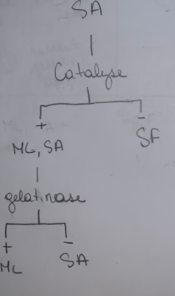
According to it the gram positive cocci were Micrococcus luteus (ML), Streptococcus faecalis (SF), and Staphylococcus aureus (SA). To isolate each one on its own for unknown A I did gelatinase and catalyze. Catalyze test isolated ML and SA as positive and SF as negative. To further isolate my two positive I chose the gelatinase test which made ML positive and SL negative for unknown A.
UNKNOWN B
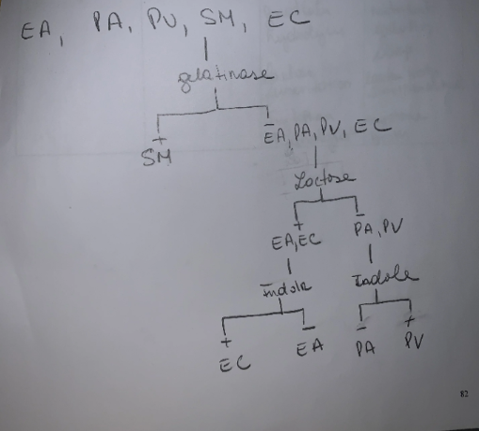
Unknown B a gram negative bacilli I got 5 possible unknowns. Enterobacter aerogenes ( EA) , Escherichia coli ( EC), Pseudomonas. Aeruginosa (PA) , Proteus vulgaris (PV) and Serratia marcescens (SM). To isolate the organisms I first did gelatinase which to only SM being positive all the other 4 were negative. To further isolate the other 4 I did a lactose test on them which mase EA, EC positive and PA, PV negative. Because I had two positive and two negative I did two separate indole test on each group. Which made EC positive and EA negative, for the negative group doing an indole test made PA negative and PV positive. The metabolic test that I requested for my unknowns A was Catalase and Gelatinase for unknown B I requested gelatinase, lactose and indole and the media were tsa slant and nutrient deep for A and for B it was nutrient gelatin deep

Reference
Das, S., Nurunnabi, T. R., Parveen, R., Mou, A. N., Islam, M. E., Islam, K. M. D., & Rahman, S. M. (2019). Isolation and characterization of indole acetic acid producing bacteria from rhizosphere soil and their effect on seed germination. Int. J. Curr. Microbiol. App. Sci, 8(3), 1237-1245.
Gajdács, M., Ábrók, M., Lázár, A., & Burián, K. (2020). Differential epidemiology and antibiotic resistance of lactose-fermenting and non-fermenting Escherichia coli: Is it just a matter of taste?. Biologia Futura, 71, 175-182.
Liao, B., Nian, W., Xi, A., & Zheng, M. (2019). Evaluation of a diagnostic test of serum Neutrophil Gelatinase-Associated Lipocalin (NGAL) and urine KIM-1 in Contrast-Induced Nephropathy (CIN). Medical science monitor: international medical journal of experimental and clinical research, 25, 565.

